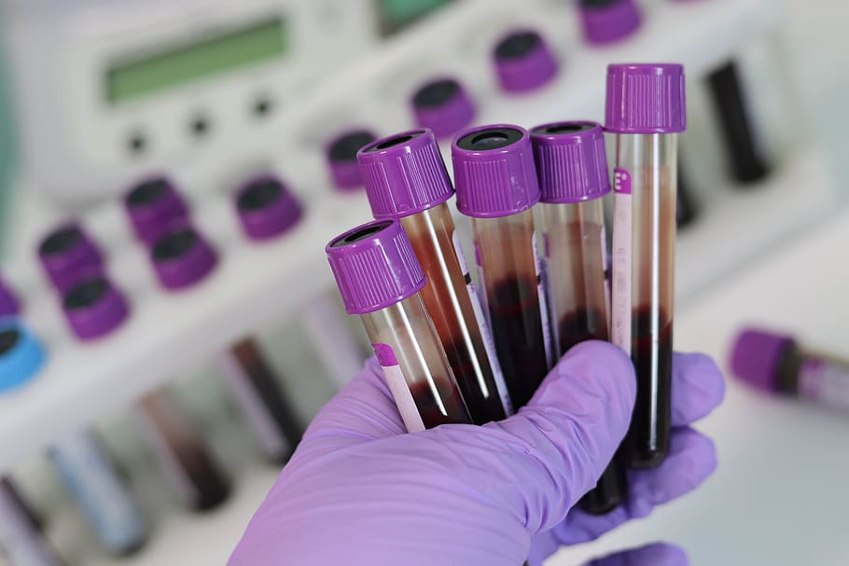
Do you have an order from your
Doctor to get lab work drawn?

MARSHALL COUNTY
HEALTH DEPARTMENT IS NOW
OFFERING LAB DRAW SERVICES.

YOU MUST HAVE AN ORDER FROM YOUR DOCTOR

Every Thursday, Marshall County Health department will draw lab work for the following tests: Complete Metabolic Panel, Lipid Panel with LDL/HDL Ratio, CBC with Diff/Platlets, Thyroid Panel with TSH, HCG (Pregnancy), Glucose, AIC, HSV 1&2, PSA Total, Antibody SARS-CoV2, Varicella Titer, Hepatitis B Titer, MMR Immunity Titer, Measles Antibodies IgG, Mumps Antibodies IgG, Rubella Antibodies IgG, and Blood Typing.

***Marshall County Health Department is NOT responsible for follow up with physicians regarding results of laboratory testing.

Laboratory results can be picked up or mailed to patients.

Oral RAPID HIV Testing is NOW abailable for $20.

There is no insurance billing for this service. It is CASH, or CREDIT/DEBIT CARD ONLY.

Fees According to Labs Ordered

Value Package $50.00
Complete Metabolic Panetl, Lipid Panel with LDL/HDL Ratio, CBC with Diff/Platlets

Comprehensive Metabolic Panel $20.00
Lipid panel with LDL/HDL/Ratio $20.00
CBS with Diff/Platelets $20.00
Thyroid Panel with TSH $30.00
HCG (Pregnancy) $25.00
Glucose $20.00
AIC $20.00
HSV 1 & 2 $100.00
PSA Total $20.00
Antibody SARS-CoV2 $50.00
Varicella Titer $40.00
MMR Immunity Titer $60.00
Measles Antibodies, IgG $20.00
Mumps Antibodies, IgG $20.00
Rubella Antibodies, IgG $20.00
Blood Typing $20.00

