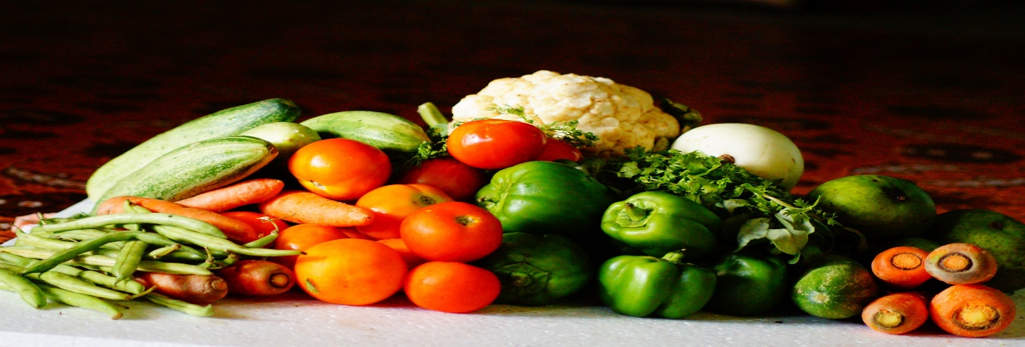

Informative Dietary Presentation
Presented by: Jill Spangler, Dietician
WVU-Reynolds Memorial Hospital

Marshall County Health Department would like to welcome the public to a free informative presentation by Jill Spangler, dietician with WVU-Reynolds Memorial Hospital.

At the Marshall County Health Department
Friday, August 12, 2022
1:30pm - 2:30pm

Jill will be speaking on a Healthy Eating Plan that will help you control your blood sugar levels. This is designed for diabetics and for anyone wanting to learn how to eat healthy.
Please call MCHD at 304-845-7840 Ext. 114 to RSVP for this FREE informative program.

